Cloud Computing

Assignments 1 and 2

# Cloud Computing Essentials



Completed Cloud Computing Essentials

1. Cloud First Steps:  
   .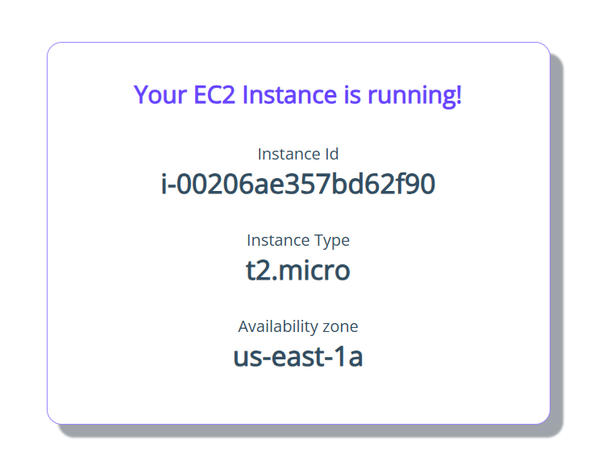

Ran the EC2 Instance Successfully

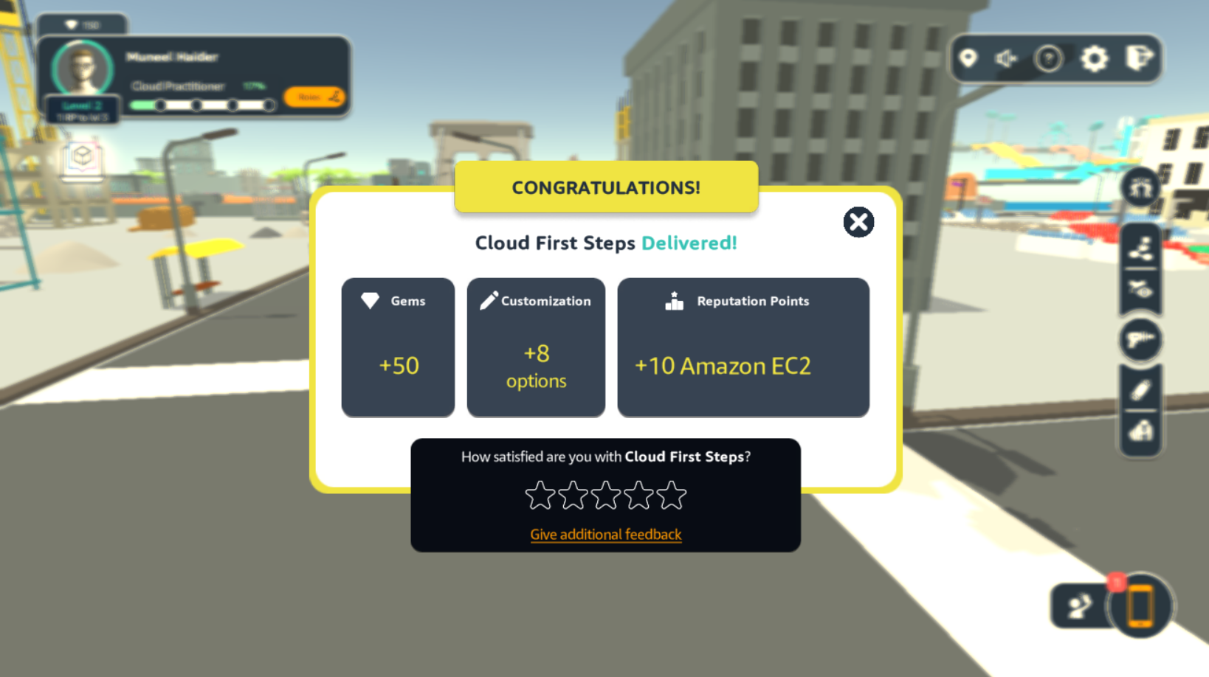

Completed the Cloud First Steps

1. Computing Solutions

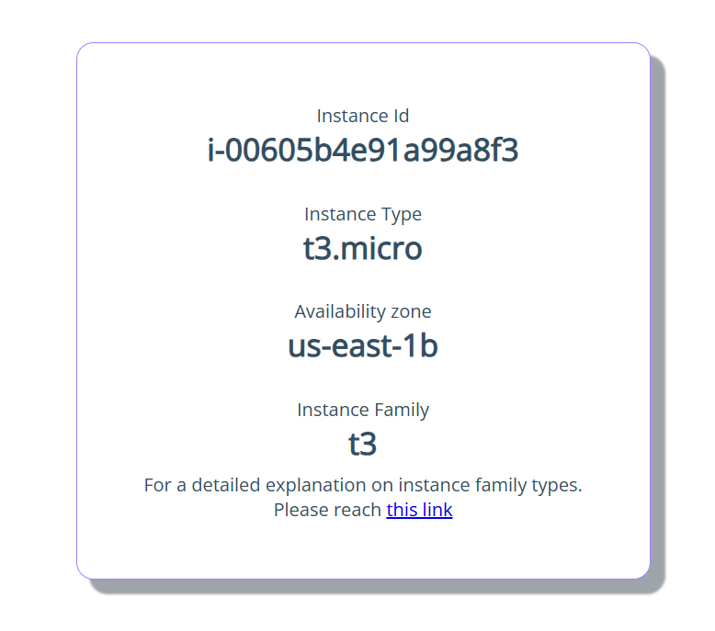

Ran the t3 instance

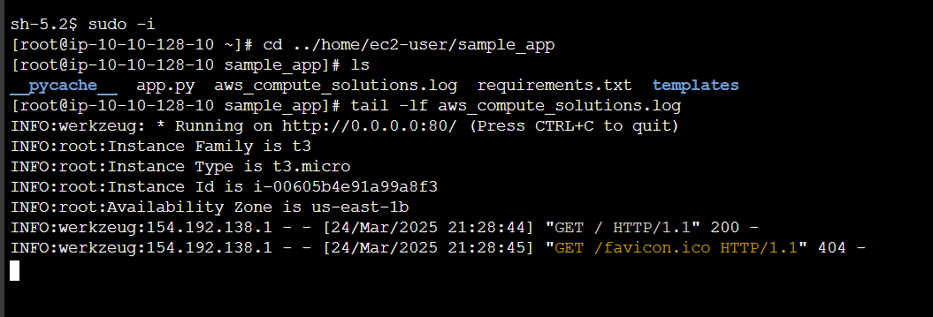

Completed the console commands

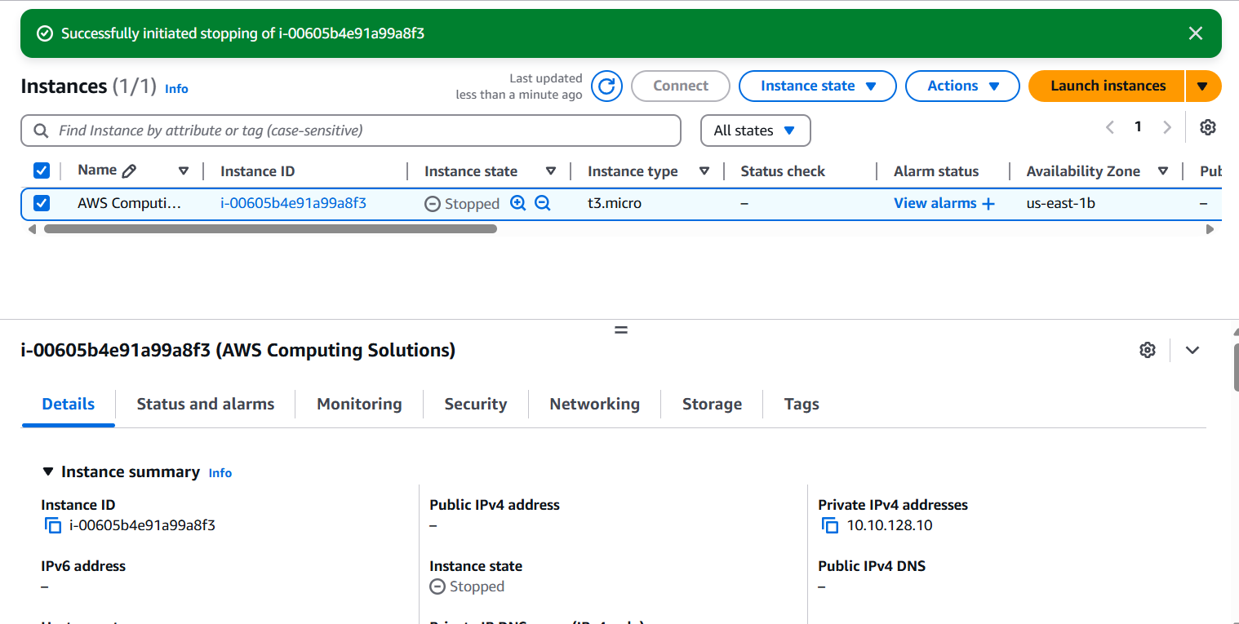

Stopped the instance

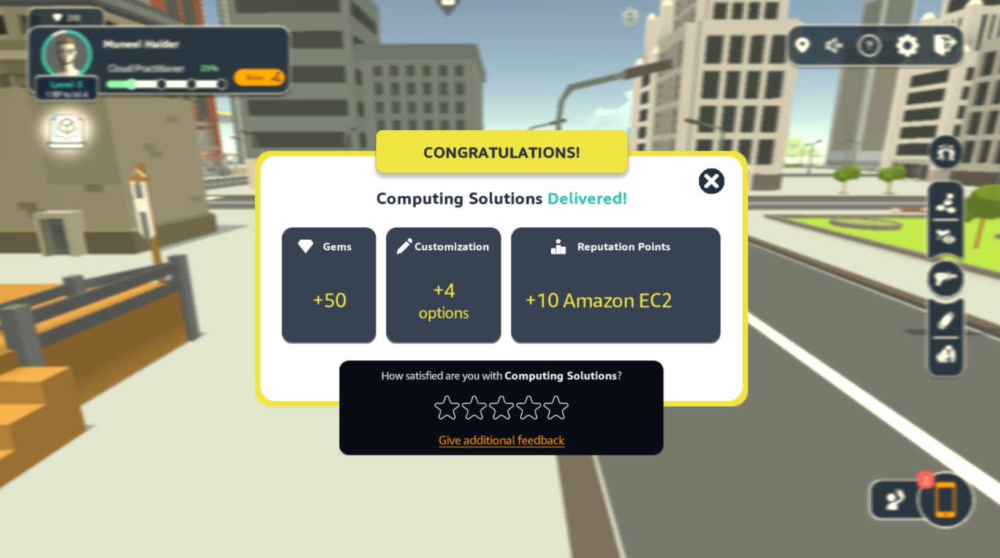

Completed Computing Solutions

1. Networking Concepts



Completed Networking Solutions

1. Cloud Economics



Completed Cloud Economics

1. Database in Practice:  
   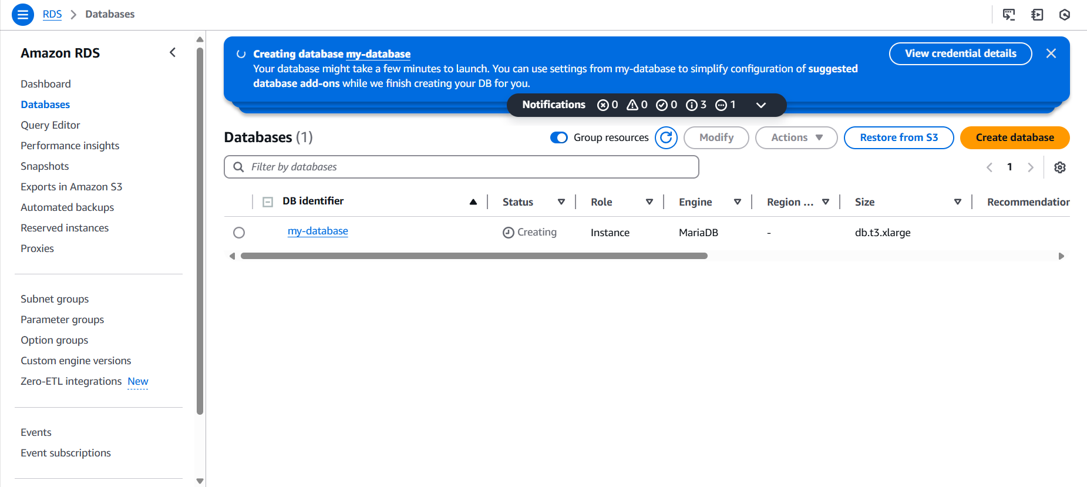

Created new database

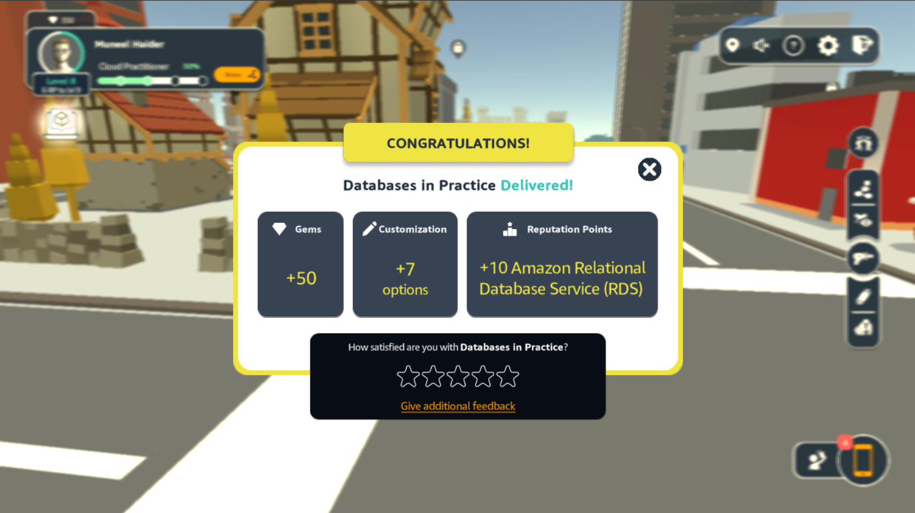

Completed Database in Practice (necessary for Core Security Concepts)

1. Core Security Concepts

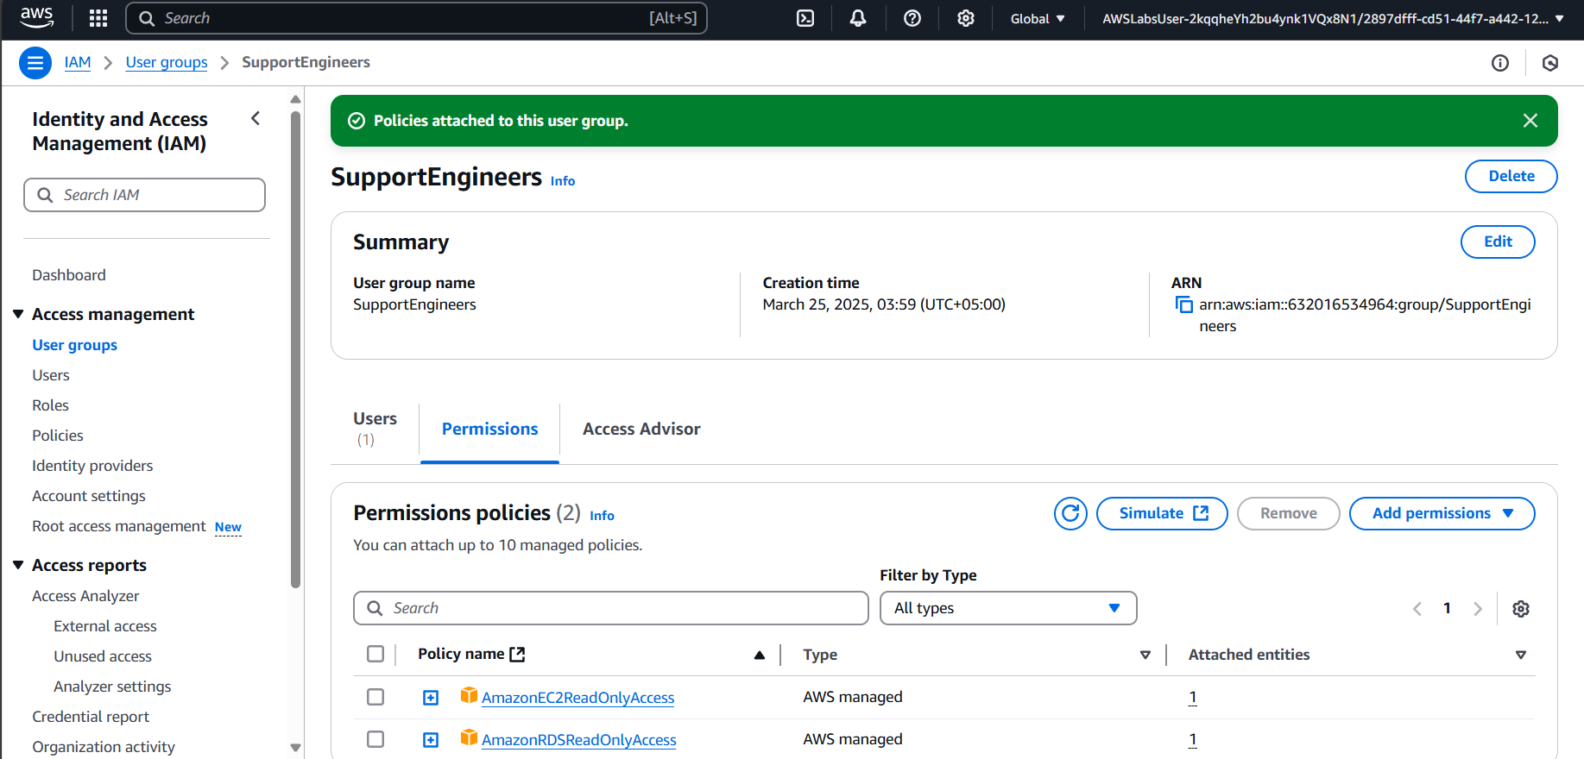

Created new User Group ‘SupportEngineers’ and added new user ‘support-engineer-1’



Completed Core Security Concepts